Electrical Overview

Year: 2022 Semester: Fall Team: 08 Project: Hermes

Creation Date: ­9/17/2022 Last Modified: September 18, 2022

Author: Michael Langford Email: mjlangfo@purdue.edu

Assignment Evaluation:

|  |  |  |  |  |
| --- | --- | --- | --- | --- |
| **Item** | **Score (0-5)** | **Weight** | **Points** | **Notes** |
| **Assignment-Specific Items** | | | | |
| **Electrical Overview** |  | x3 |  |  |
| **Electrical Considerations** |  | x3 |  |  |
| **Interface Considerations** |  | x3 |  |  |
| **System Block Diagram** |  | x3 |  |  |
| **Writing-Specific Items** | | | | |
| **Spelling and Grammar** |  | x2 |  |  |
| **Formatting and Citations** |  | x1 |  |  |
| **Figures and Graphs** |  | x2 |  |  |
| **Technical Writing Style** |  | x3 |  |  |
| **Total Score** |  | | |  |

5: Excellent 4: Good 3: Acceptable 2: Poor 1: Very Poor 0: Not attempted

General Comments:

*Relevant overall comments about the paper will be included here*

1.0 Electrical Overview

The primary functionality of the flight controller is driven by a few critical electronic subsystems. Processing of the input data to control the motors will be accomplished by a 3.3V 32 bit microcontroller with 100MHz+ processing rate. An external crystal will provide a stable clock signal, and external programming header will provide access to reflash the micro. The microcontroller will interface to on-PCB devices including a 6 axis IMU, UART to USB controller, LIDAR range sensors and power conditioning circuitry. Power supply circuitry consists of a 5V regulator, 3.3V LDO regulator, and voltage spike protection capacitors and diodes. IMU data will be accessed via a 2 MHz speed SPI bus, and LIDAR via I2C. An optional smaller micro will output log data from the main micro transmitted via UART to log it on an optional SD card during flight for purposes of diagnostics after flights.

It will interface to external devices as well, namely a radio receiver, a motor controller, and a Raspberry Pi. The radio receiver will be connected atop the flight controller and interfaced via a UART physical protocol and CRSF (aka Crossfire) over UART. The Pi will communicate via UART as well. The motor controller will be interfaced via cable to the flight controller, and will communicate motor speed commands via DSHOT protocol, which is a digital serial protocol.

Internal to the flight controller microcontroller, the device will perform acquisition of sensor data via DMA, processing via complementary filter or Kalman filter algorithm, and process motor commands using PID loops and output to motor controller (ESC) via DMA as well. The flight controller will use the LIDAR range data to move a set distance from the wall and floor via other PID loops.

2.0 Electrical Considerations

2.1 Operating Frequency

The first driver of microcontroller electrical requirements is the operation frequency of the micro. Due to the proliferation of flight controllers on the market is very easy to determine what a decent clock rate for acceptable performance is, which seems to be in the 80MHz-200MHz range. See citations for flight controller data. To this end, a target clock frequency for a microcontroller was selected as 120MHz or higher.

To ensure rapid processing of image frames from the camera, a Pi Zero single-board computer with GHz+ clock speed was chosen to accomplish the processing.

2.2 Power Budget

|  |  |  |  |  |
| --- | --- | --- | --- | --- |
| Supply | Device | Current Typ [mA] | Current Min [mA] | Current Max [mA] |
| 4S Battery | Motor controller(ESC) | 400 | 400 | 400 |
|  | Motors | 26000 | 13000 | 38000 |
|  | 10V Supply | 439.6 | 184.2 | 567.6 |
| 10V Supply | 5V Supply | 424.6 | 169.2 | 552.6 |
|  | Power LED | 15 | 15 | 15 |
| 5V Supply | Radio Receiver | 3.4 | 3.4 | 3.4 |
|  | Pi Zero | 200 | 50 | 250 |
|  | Camera | 100 | 50 | 150 |
|  | Power LED | 15 | 15 | 15 |
|  | 3.3V Supply | 106.2 | 50.8 | 134.2 |
| 3.3V Supply | STM32 Microcontroller | 80 | 30 | 100 |
|  | LSM6DSR 6-axis IMU | 1.2 | 0.8 | 1.2 |
|  | FT230XQ UART to USB | 8 | 5 | 8 |
|  | Power LED | 15 | 15 | 15 |
|  | RX/TX LED | 2 | 0 | 10 |
| Total Current [mA] |  | 26839.6 | 13584.2 | 38967.6 |
| Total Current [A] |  | 26.84 | 13.58 | 38.97 |

3.0 Interface Considerations

As to communication frequencies in other areas, the bus speed for the SPI connection to the IMU is very important. To ensure the bus speed is never a bottleneck to IMU data acquisition, the target bus speed is set to allow multiple byte transfers before the next gyro/accelerometer reading is available, i.e. 2MHz.

The baudrate of the radio receiver is dictated by the radio protocol, which sets it to 400,000 baud. The I2C rate to the LIDAR range sensors is not incredibly important, provided it exceeds a few kilobaud, provided it is run in the background via DMA. The other UART connections have similarly little restriction on baudrate, with a 9600 baud for debug UART being acceptable, and well as the UART from flight controller to navigation computer needing 115200 baud to ensure enough full frames per second of IMU data.

4.0 Sources Cited:

Oscar Liang. 2022. *F1, F3, F4, G4, F7 and H7 Flight Controller Processors Explained - Oscar Liang*. [online] Available at: <https://oscarliang.com/f1-f3-f4-flight-controller/> [Accessed 18 September 2022].

Appendix 1: System Block Diagram

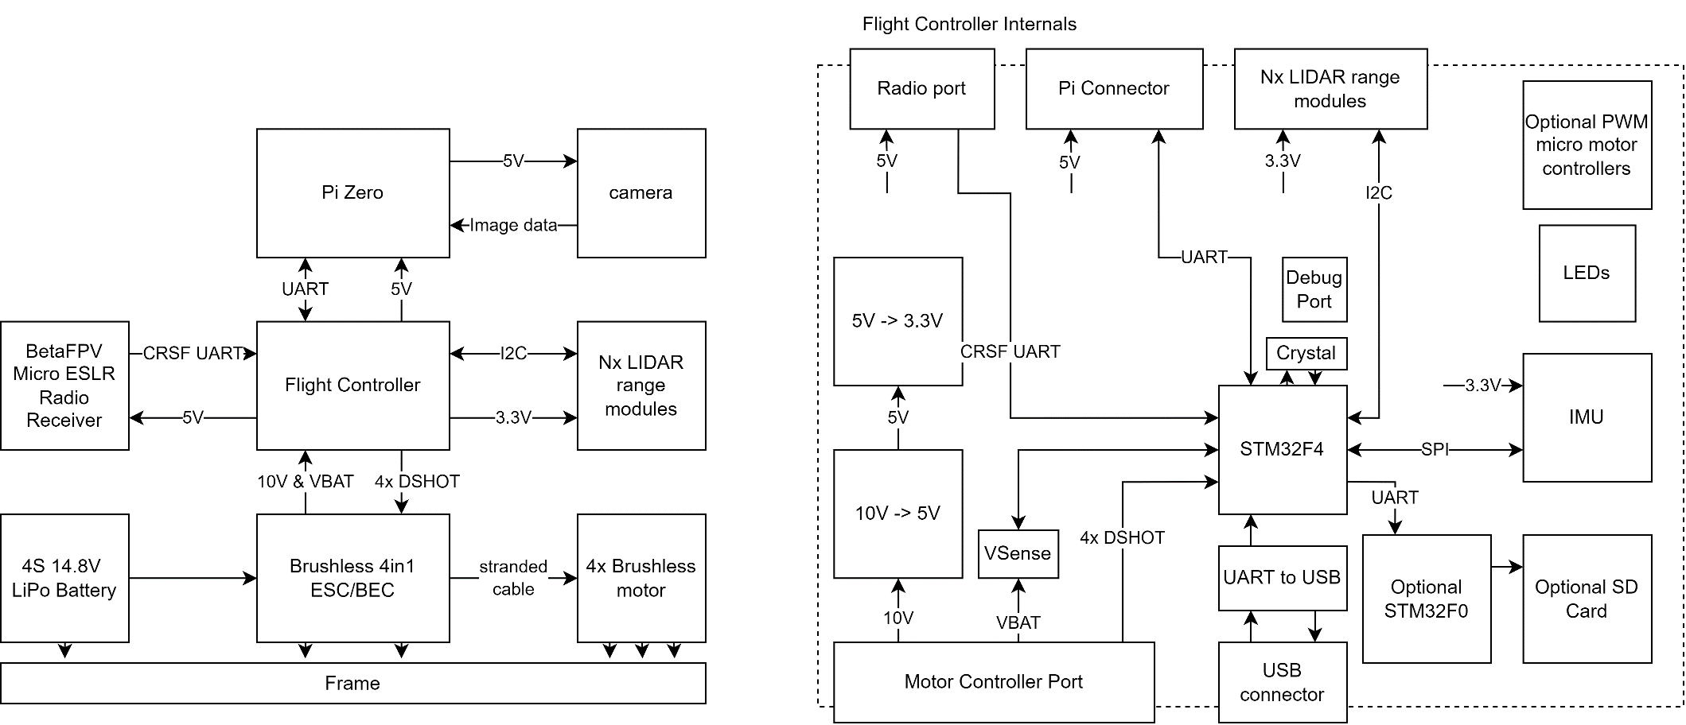

Fig. 1. System Block Diagram

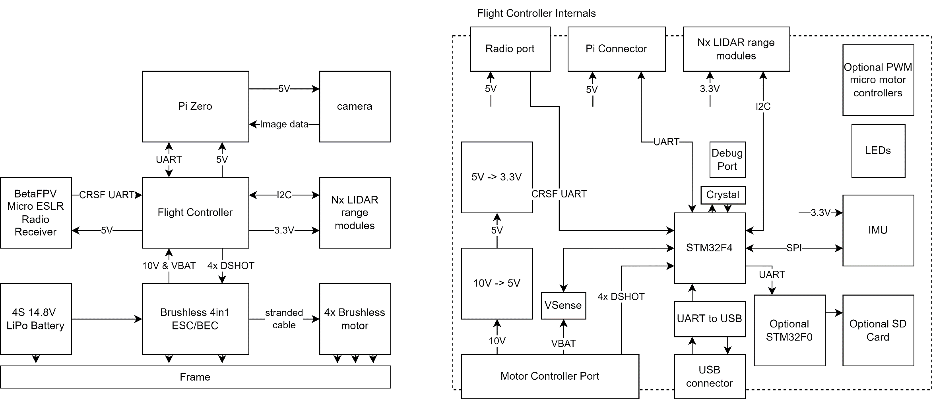

Fig. 2. Flight Controller Block Diagram